March 14, 2022 BAC Board Minutes
Recorded by Jeff Wolfe (Lyndi sick today)
The purpose of the Bitterroot Aquatic Center is to provide the community with a high quality year-round aquatic center that is affordable, accessible and provides excellent opportunities for recreation, fitness, competition, water safety, and education.

- Meeting open at 6:30
Commissioners present: Ryal Weber, Jeff Wolfe, Karen Savory, Marilyn Wildey
Commissioners absent: Vicky Mahon, Carla Albert
Guest: Amy Reed
No other attendees, Fern on vacation
Read Mission Statement
- Housekeeping
Introduce Amy, ask those present to introduce themselves and a little about their experience on the board.
Review, amend as needed and adopt February minutes.
Marilyn had one edit: to let the president know of any additions to the calendar.
- Recognizing retiring commissioners
Plaques from Elaine’s Engraving ranged from about $60 -$80, pictures of options were shown. Marilyn proposed a clock for those commissioners that served multiple terms. Possible display showing past board members names and dates for hanging in the front area. Amy suggested tiles in the Commons Area, pending further review. Also gift certificates for retiring commissioners amount depending upon length of time served. The board thought the tile suggestion and gift certificate idea was better as would be ‘useful’. Marilyn will look into pricing/availability of tiles and gift certificates.
- Foundation update
- Karen reported that the Foundation applied for 2 grants this month: REC and Rapp Family for $5000 each. If received money would be used to fund playground equipment. A Hamilton High School senior is volunteering to post information on social media. Andrea is working to get the Foundation set up to be part of the Bitterroot Gives donation day. Looking for matching donors, if any of the commissioners know of someone to let her know. If grants are received the planground would be installed the end of 2022.
- The tentative date for the summer community event is June 11. The Foundation is looking for help from the commissioners. A planning meeting will be 8:00, Wednesday, March 23. Fern, Marilyn and Amy plan to attend.
- Maintenance Committee update
Ryal reported that heat exchanger has been repaired but waiting for additional parts to fully fix. The building is hotter than normal until repairs are finalized. Two picnic tables have been ordered to replace older failing wooden tables.
- Update on new commissioners, interim position
- Three candidates volunteered to be on the pool commission, Amy Reed, Ron Frost and Sara Morin. As only three 3 were interested, no election is needed. Amy works out of town each summer but can participate in meetings via Zoom.
- Amy and Ron both expressed interest in the interim position left by the retirement of Loretta Bundy. Ron had submitted a resume and Amy discussed her desire to serve. Amy was excused temporarily from the meeting while a discussion was held on filling the interim position. The board chose Amy as she works out of town during the summers and by installing her now we could get her started and get some ideas from her before she leaves town.
- Marilyn will contact Ron to let him know of the decision. Amy returned to the meeting.
- Manager’s Report
- Fern is on vacation but left a list (attached to minutes) for discussion.
- Early in March Fern discussed with Marilyn an issue the pool is having with 2 year old kids being registered for 3 year old group classes. Often the young children create discipline and safety issues as their attention span is much shorter and end up hold back the rest of the class. Fern is looking for some ideas to solve this. Suggestions were: requiring birth certificates to document correct age, email from a health care provider, raising the cost of lesson and offering a discount when birth certificate provided, including a signed form from parent stating that their child is 3 and capable of learning in a group situation. Some suggested wording: “I agree that X is three years old and able to follow directions to allow class to progress at a rate appropriate for beginning young swimmers. If X is creating safety issues due to inability to follow directions he/she will be removed from class and enrolled in the next available class six months from now at no additional cost. It will be my responsibility as the parent to contact the BAC in six months to arrange for X to be enrolled in the class.” Marilyn will bring these ideas to Fern to see if any might be the solution.
- Bonfire location-no additional information on this topic. Marilyn will check with Fern to see if she has talked with school about the fact that we don’t want to hold the bonfire on pool property due to safety issues resulting from housing development around the site.

- Other information
- Karen brought forward a thank you from a mother of a child with Autism. She was so thankful that the pool staff were so helpful in allowing her child to dress at the pool so he could swim.
- Andrea Price, one of the Foundation board members is leaving town for an extended travel vacation and may not return. She will participate via Zoom until her future plans are finalized. If she were to resign, we would need to find another board member.

See attached Managers Report, below
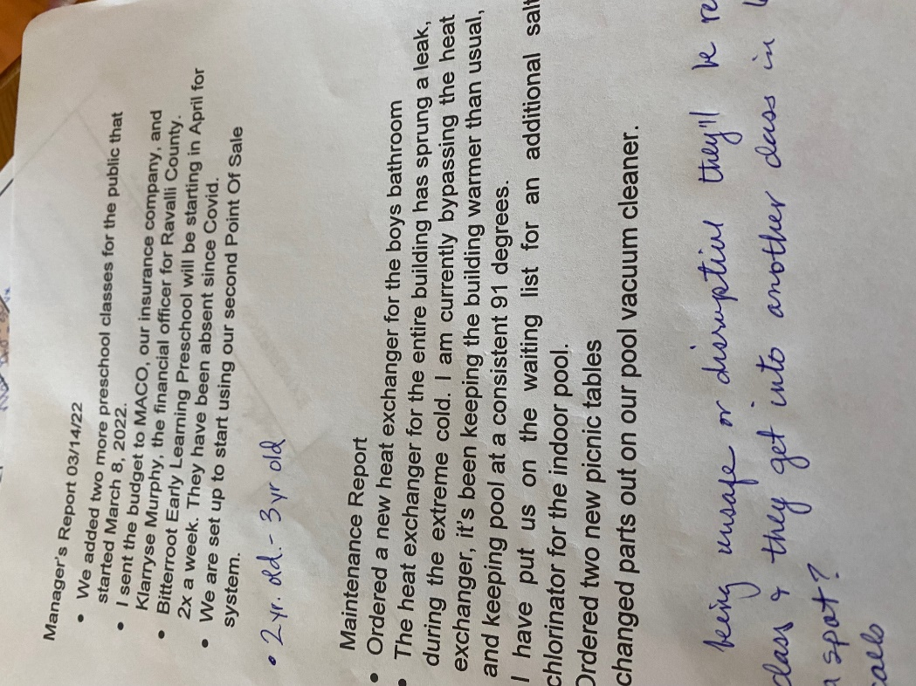

ADJOURN
Karen moved to adjourn at 7:19, Ryal seconded, all approved.

Next Meeting: Monday, April 11 at 6:30 PM Plan for Bryon’s evaluation

